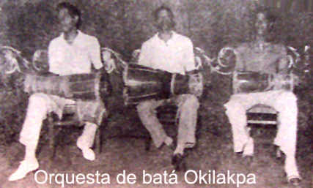
The above picture is said to be of Miguel Somodeville, Trinidad Torregosa, Jose C Valdes Frias (Moñito), any clue as to who is who?

